На Чериковщине прошел областной туристический слет «Чериковский привал-2023»

[](https://www.cherikovnews.by/wp-content/uploads/2023/06/4-13.jpg?v=1687524942)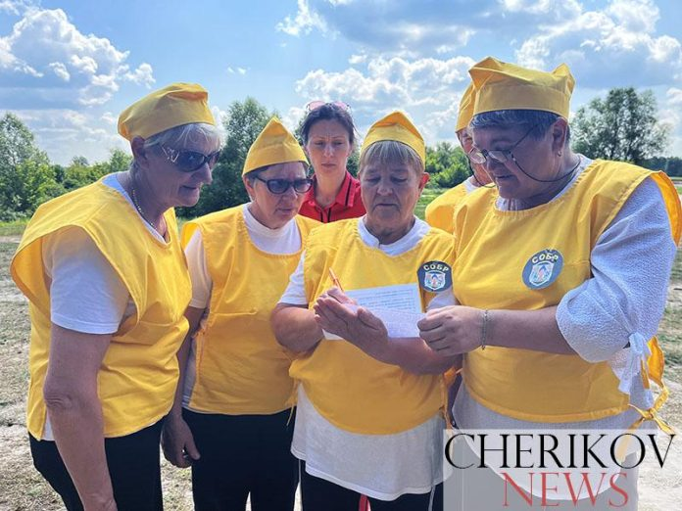23.06.2023 [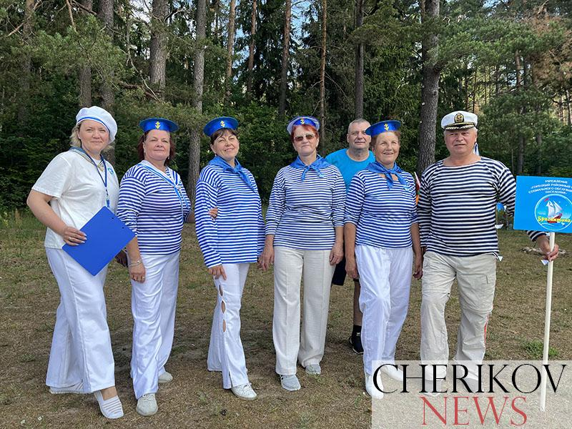](https://www.cherikovnews.by/wp-content/uploads/2023/06/2-20.jpg?v=1687524937)[](https://www.cherikovnews.by/wp-content/uploads/2023/06/3-18.jpg?v=1687524939)[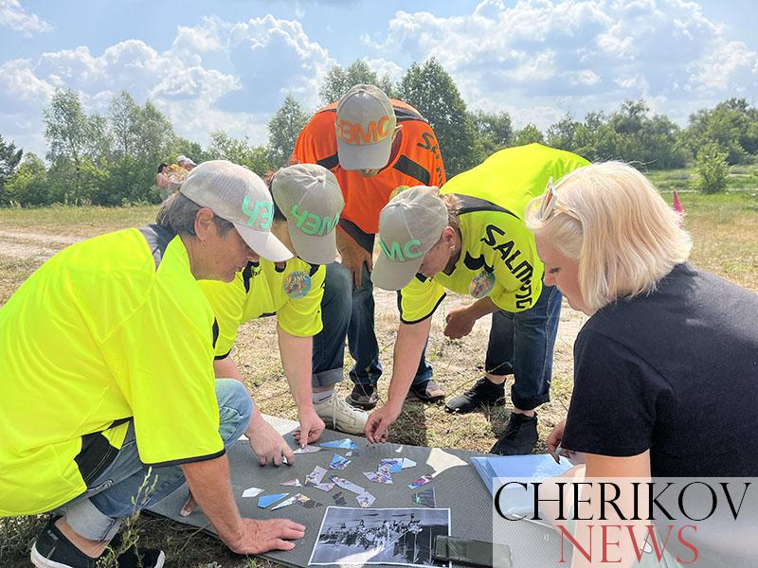](https://www.cherikovnews.by/wp-content/uploads/2023/06/13-5.jpg?v=1687524974)[](https://www.cherikovnews.by/wp-content/uploads/2023/06/6-13.jpg?v=1687524947)[](https://www.cherikovnews.by/wp-content/uploads/2023/06/5-13.jpg?v=1687524944)

[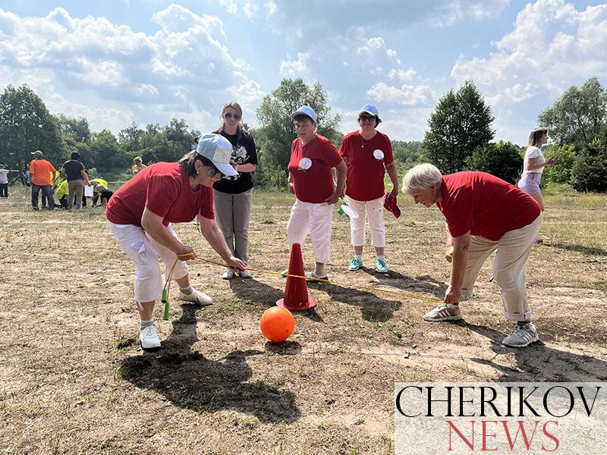](https://www.cherikovnews.by/wp-content/uploads/2023/06/12-6.jpg?v=1687524972)[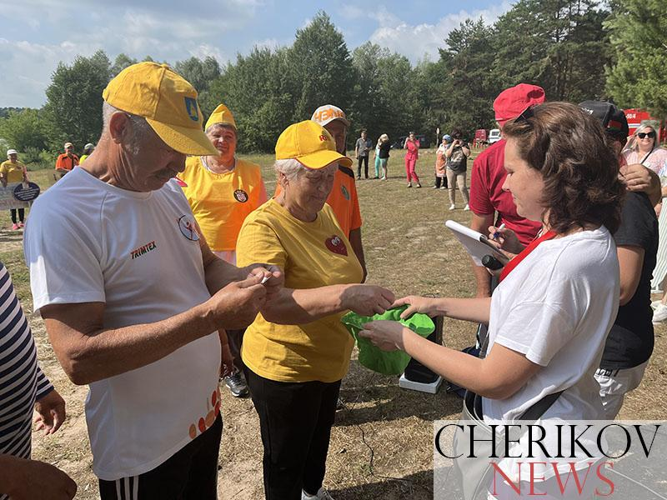](https://www.cherikovnews.by/wp-content/uploads/2023/06/7-10.jpg?v=1687524949)[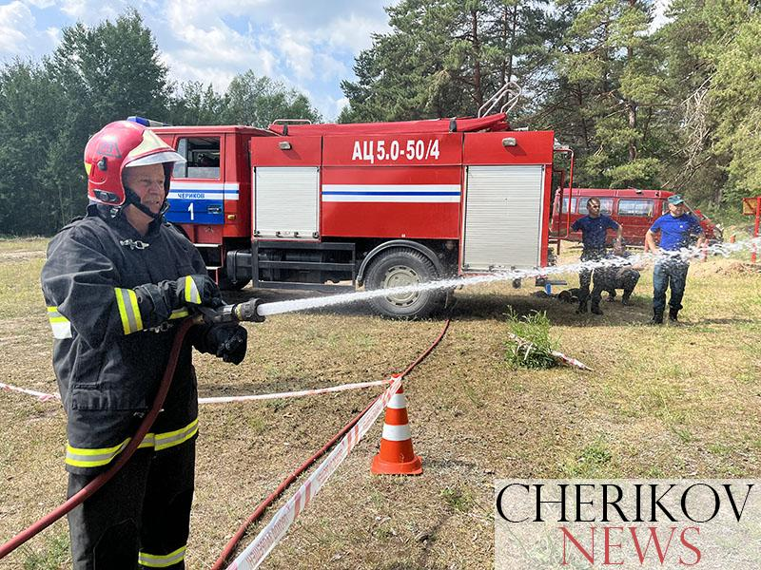](https://www.cherikovnews.by/wp-content/uploads/2023/06/11-7.jpg?v=1687524971)[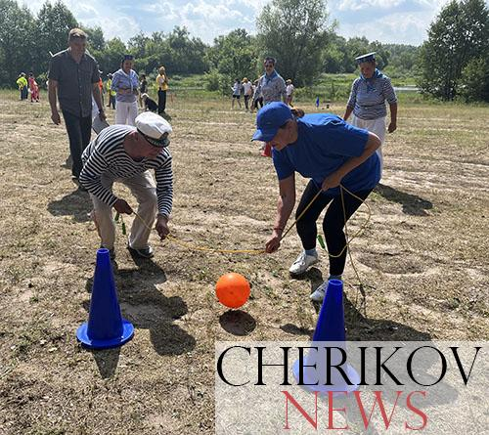](https://www.cherikovnews.by/wp-content/uploads/2023/06/15-5.jpg?v=1687524977)

[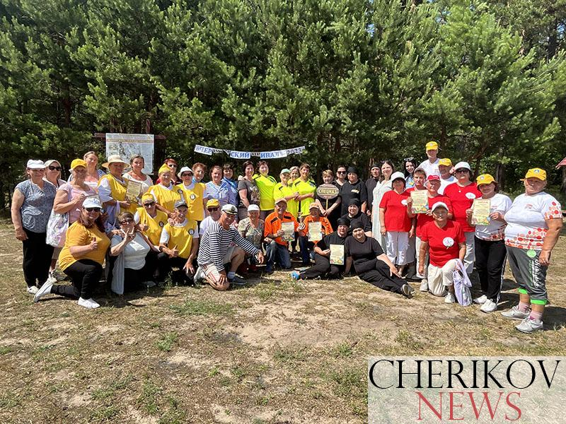](https://www.cherikovnews.by/wp-content/uploads/2023/06/60-1.jpg?v=1687527028)[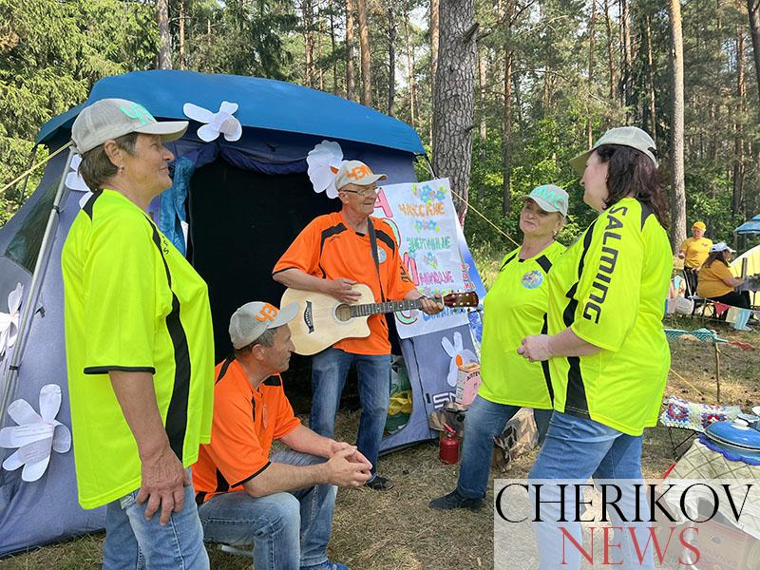](https://www.cherikovnews.by/wp-content/uploads/2023/06/25-4.jpg?v=1687525029)

[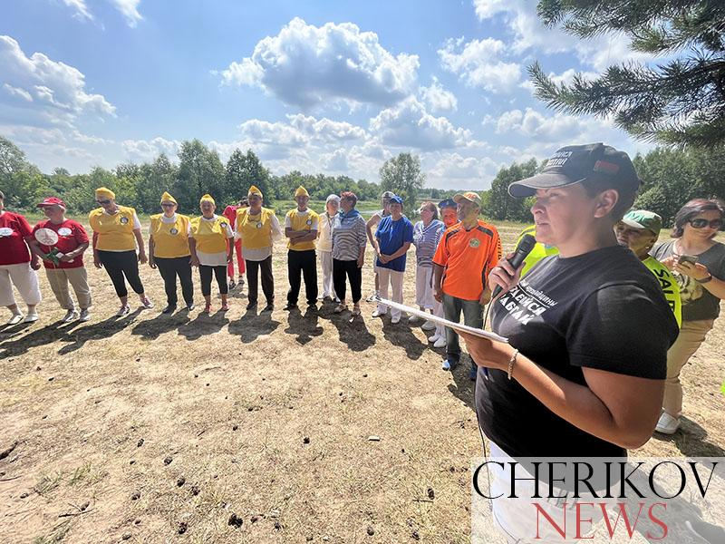](https://www.cherikovnews.by/wp-content/uploads/2023/06/26-4.jpg?v=1687525033)[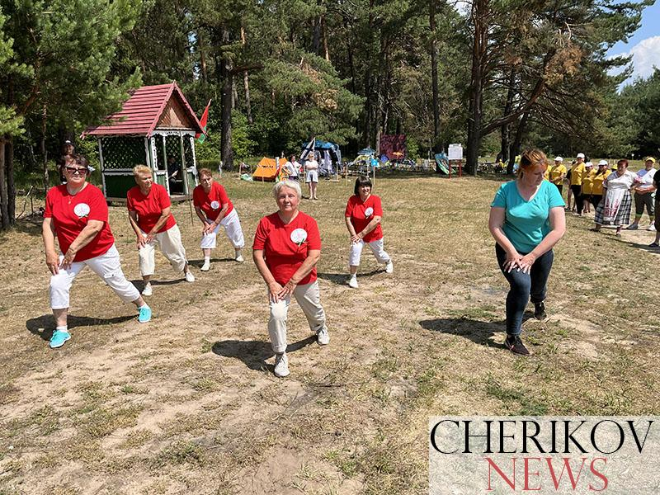](https://www.cherikovnews.by/wp-content/uploads/2023/06/34-1.jpg?v=1687525270)[](https://www.cherikovnews.by/wp-content/uploads/2023/06/51-1.jpg?v=1687527016)