«Показали физическую подготовку, мастерство и командный дух». В Черикове прошли районные соревнования среди санитарных и добровольных пожарных дружин

09.06.2023

[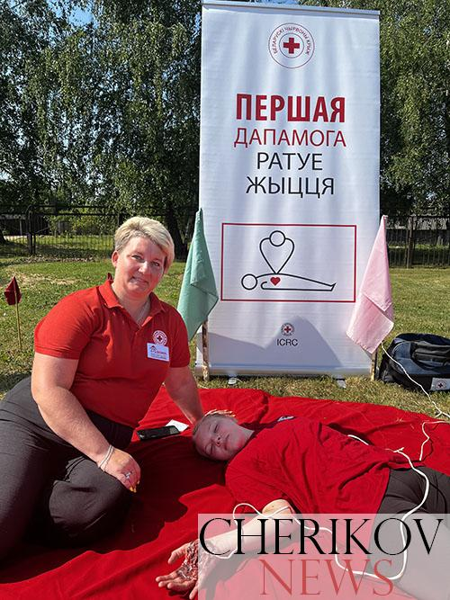](https://www.cherikovnews.by/wp-content/uploads/2023/06/3-5.jpg?v=1686315700)[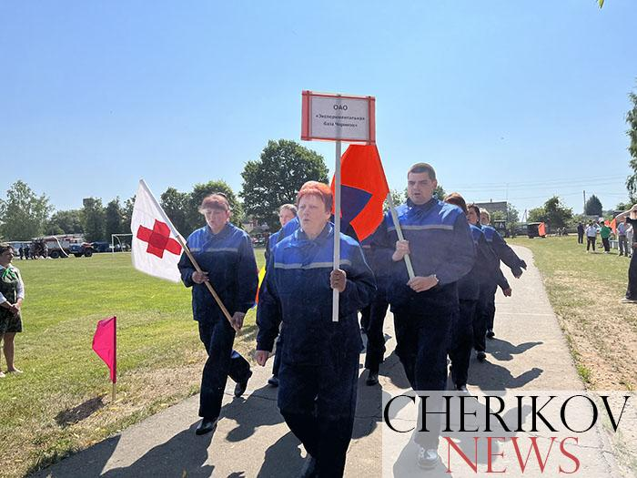](https://www.cherikovnews.by/wp-content/uploads/2023/06/14-2.jpg?v=1686315977)[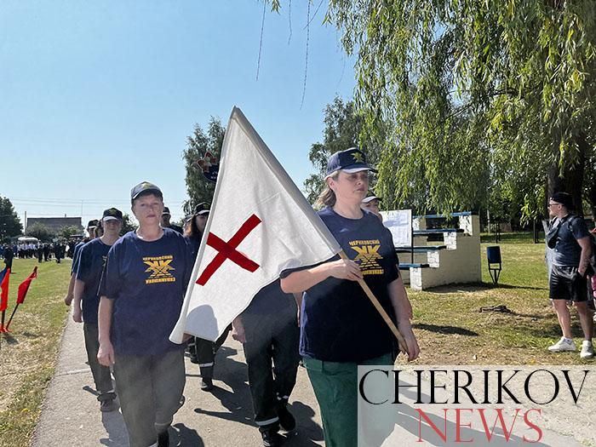](https://www.cherikovnews.by/wp-content/uploads/2023/06/8-3.jpg?v=1686315721)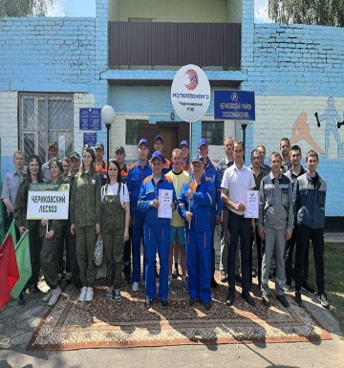

[](https://www.cherikovnews.by/wp-content/uploads/2023/06/13-2.jpg?v=1686315964)[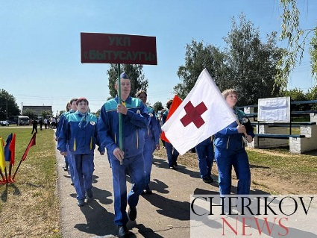](https://www.cherikovnews.by/wp-content/uploads/2023/06/12-2.jpg?v=1686315963)

[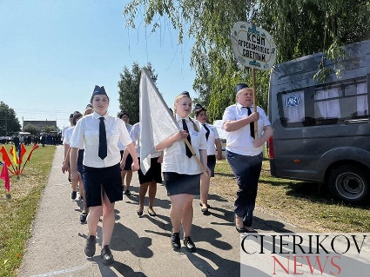](https://www.cherikovnews.by/wp-content/uploads/2023/06/5-4.jpg?v=1686315706)[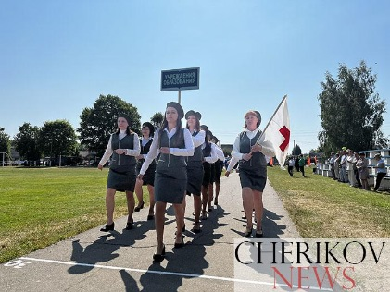](https://www.cherikovnews.by/wp-content/uploads/2023/06/11-3.jpg?v=1686315962)

[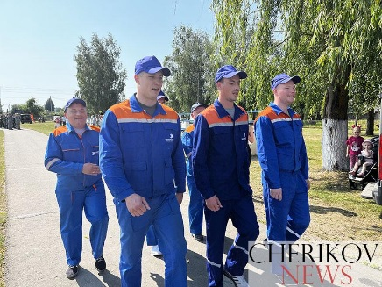](https://www.cherikovnews.by/wp-content/uploads/2023/06/9-3.jpg?v=1686315776)[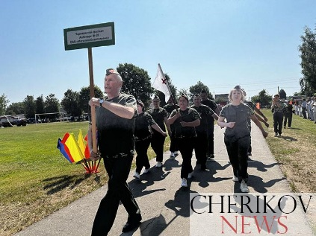](https://www.cherikovnews.by/wp-content/uploads/2023/06/10-5.jpg?v=1686315960)[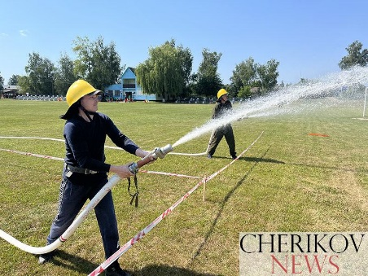](https://www.cherikovnews.by/wp-content/uploads/2023/06/20-2.jpg?v=1686316342)

[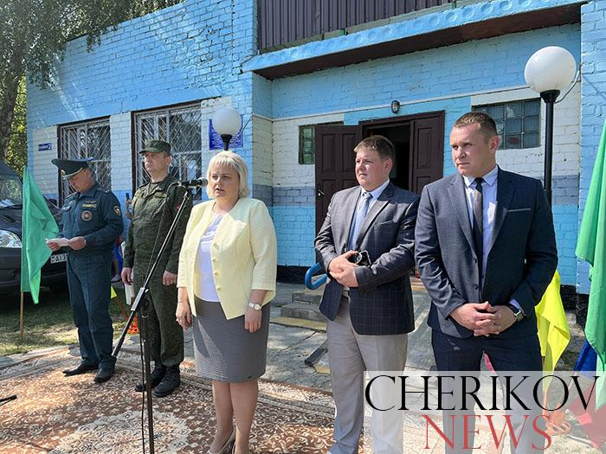](https://www.cherikovnews.by/wp-content/uploads/2023/06/16-1.jpg?v=1686315985)[](https://www.cherikovnews.by/wp-content/uploads/2023/06/17-1.jpg?v=1686316059)[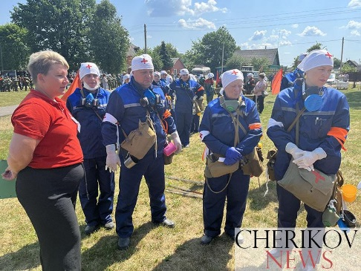](https://www.cherikovnews.by/wp-content/uploads/2023/06/37.jpg?v=1686316764)

[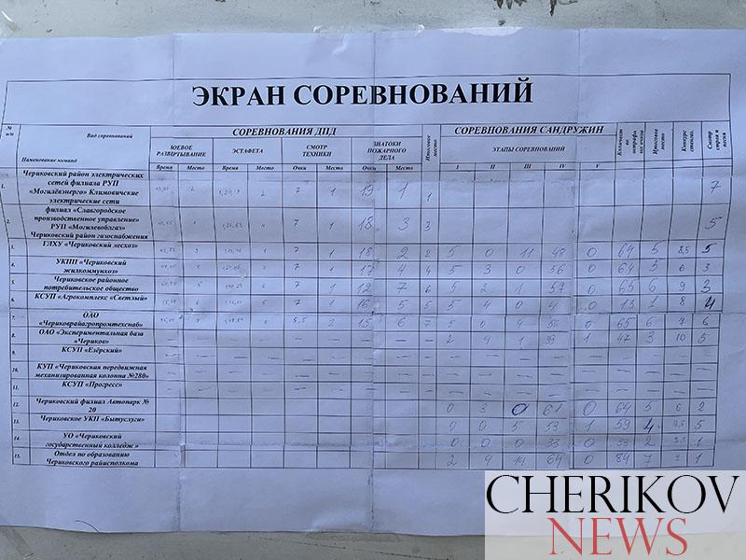](https://www.cherikovnews.by/wp-content/uploads/2023/06/47.jpg?v=1686317207)

[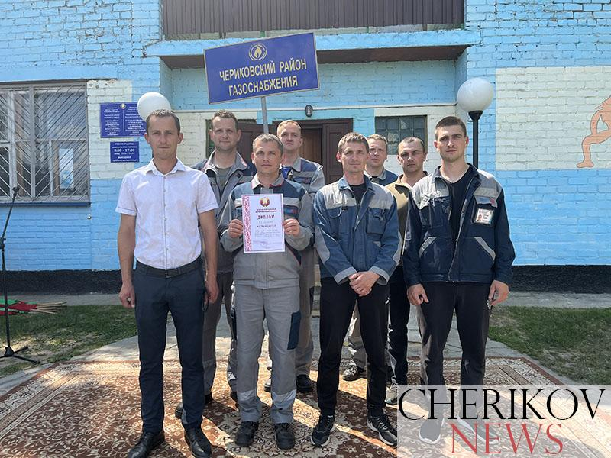](https://www.cherikovnews.by/wp-content/uploads/2023/06/60.jpg?v=1686318192)[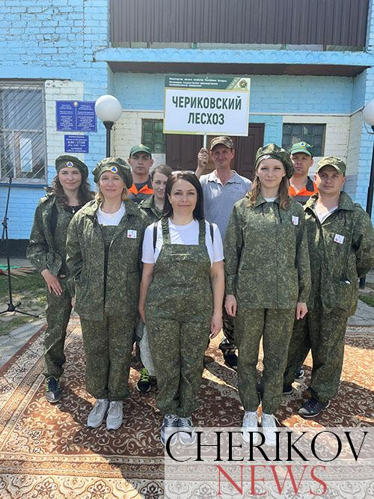](https://www.cherikovnews.by/wp-content/uploads/2023/06/61.jpg?v=1686318194)